暨 南 大 学
本科生课程论文

论文题目： Software Engineering Curricular Report—Developing a Tally Application

学 院： 智能科学与工程学院
学 系：
专 业： 信息安全
课程名称： 软件工程
学生姓名： 钱子仪
学 号： 2019052855
指导教师： 龚雪沅

2022年 1 月 10日
Software Engineering Curricular Report—Developing a Tally Application
Abstract: After learning throughout the semester, I have gained much knowledge about software engineering and successfully developed an application as a group. What we have developed is a tally application with multiple functions including recording and deleting accounts, statistics of monthly account, searching for a specific category of account, summoning chart of accounts and so on. My duty in the project is software engineer, who is responsible of most of the development and implementation of functions.
Keywords: Android Studio, java, SQLite database, Android basic layout, customed keyboard, Fragment layout, Bar chart
GitHub Link: https://github.com/OkraTempura/SoftwareEngineeringTask.git

Introduction

1.1 About the Application
The tally application is developed on Android Studio and is based on JAVA. Its basic function is that user can note down accounts including deciding the type of the account (snacks, every-day use, salary, travel, etc.), date of the account and remarks if necessary. Furthermore, monthly income and expenses can be calculated and demonstrated through a bar chart. There are also functions of presenting history accounts and clear all accounts. By the way, we were intended to make an searching function but failed to implement it due to technical limitation.
The interface of the application is rather succinct and quite easy to use. However, although the finished application has no fatal problems, I found out a lack of fluency while running on the Android emulator. Whether or no, I think it’s functional and stable enough to put into use.

1.2 Functioning Instance
Below I will show some screenshots of functioning the facilities of the application.
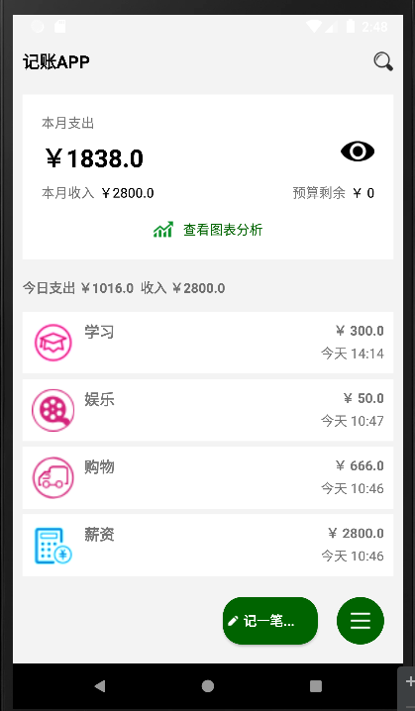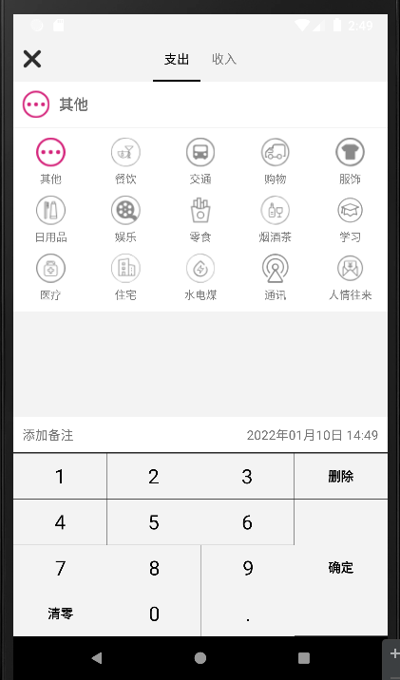
1. Main Interface 2.Add Account
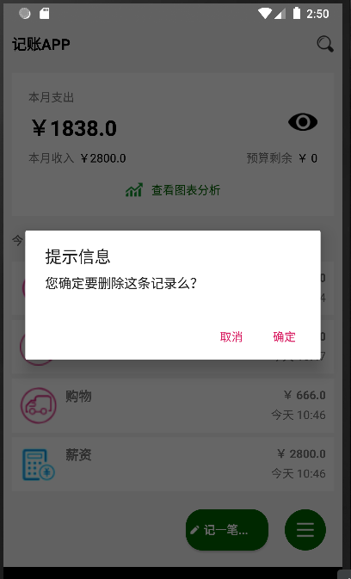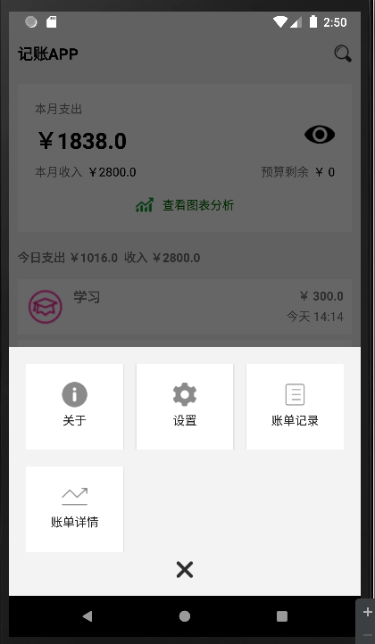
3.Delete an Account 4.More
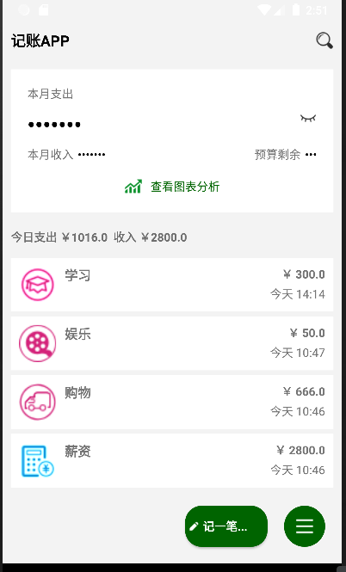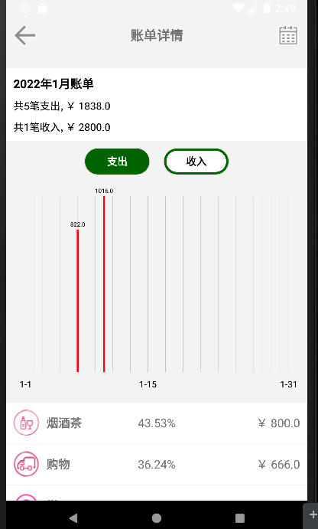
5.Hide income and expenses 6.Bar Chart of Monthly Account

What I have learnt

2.1 Usage of Git
As a project requires teamwork, there will be much trouble arranging every member’ s obligation and managing codes of the project. Here we need to use Git to have a good arrangement of all codes. With sharing a same remote repository, group member can either commit their own changes or pull the newest version of the project. There’ s also an visualization application called “TortoiseGit” providing much convenience to use Git. Throughout the procedure of our development, I usually take advantage of TortoiseGit to push codes to the Github repository.

2.2 Product Vision
At the beginning of the project, we need to decide what application we would like to develop. This part of work is mainly done by the product manager. During our first discussion, we were intended to develop a integration software with functions of both calculator and memorandum. But after a series of assumptions we found out that it is hard to make it integrated naturally and functional, and the interface layout would be quite messy due to the great difference in appearance of the two functions.
In conclusion we eventually decided to develop a tally application on mobile devices and chose Android Studio as our development platform.
During the design of the software product, we have learnt that there are three key factors: features, scenarios and user stories.
For features we didn’t expect much at the beginning, just planning to implement the basic function of a tally application—recording, deleting and examining history accounts. In this aspect, the product has been produced as we anticipated and additionally implemented a bar chart statistics section.
For the scenario and user stories which should be written from the user’ s perspective, we assumed two classic personas. One is named David who possesses a large amount of wealthy while is rather careless, another is named Jack who lives a situation of scarcity and requires elaborate arrangement of his wealthy. Following is the completed user scenario.
1.David’ s scenario:
David is an executive of a company who possesses large wealthy. In his times off work he likes to hang out with friends, causing that he makes quite a large amount of accounts. Furthermore, some of his friends often borrow money from him.

For a long period, David has being vexed by managing his outcomes. Actually, he spent money so frequently that he couldn’ t inspect the flow of his fund, either could he remember when and which of his friends borrowed his money.

One day, he found the tally application, in which he found it convenient to note down his incomes and expenses, also have a intuitionistic view of when and where he made the account, as he can set the date and category of a certain account himself in the application.

He starts to use the tally application frequently and gradually have a better management of his own wealthy.
2.Jack’s scenario:
Jack is a graduate student who is making a live on his own. He lives in a let and does part-time job every day. Every penny in his pocket should be spent carefully considering his situation.

Jack is being annoyed. He either spend too much or too little every month and can not take control of his money. If he has enough money left last month, he will buy several things to meliorate his basic living, while he might buy too much that he has less money to use next month.

After David found and started using the tally application, he can set a total amount of his property and is able to check the usage after every account made. From the in he lives a more regular life financially.

2.3 Software Architecture
After the design of product visions, we started wo design the structure of our application and working on the class diagram which shows the general classes in the project. This part is mainly done by me as the software engineer.
I designed a MainActivity class to implement the functions and demonstrate parts and data in homepage, a HistoryActivity to implement examining history accounts, and a RecordActivity to implement functions of adding accounts.
In the process of programming, there are several more classes added into the program: MonthChartActivity for the bar chart function, SettingActiviy for settings window(with only one function though), AboutActivity for “about” window showing application profiles, and a series of functional classes such as classes implementing chart, fragment layout, adapter and SQLite database. Following pictures shows all the classes used in the application.
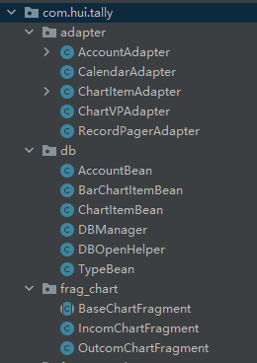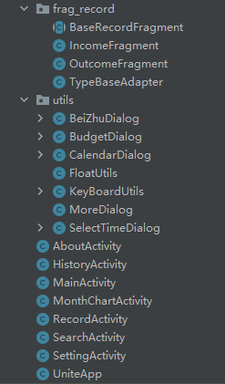
During the development of the software in android studio, we not only should work on core functional codes, but also designing layouts in the given xml files. For the account list in homepage I use RealtiveLayout and ListView widget wo implement. As the most important part, the keyboard uses its specific widget called KeyboardView. The following is how it is designed.
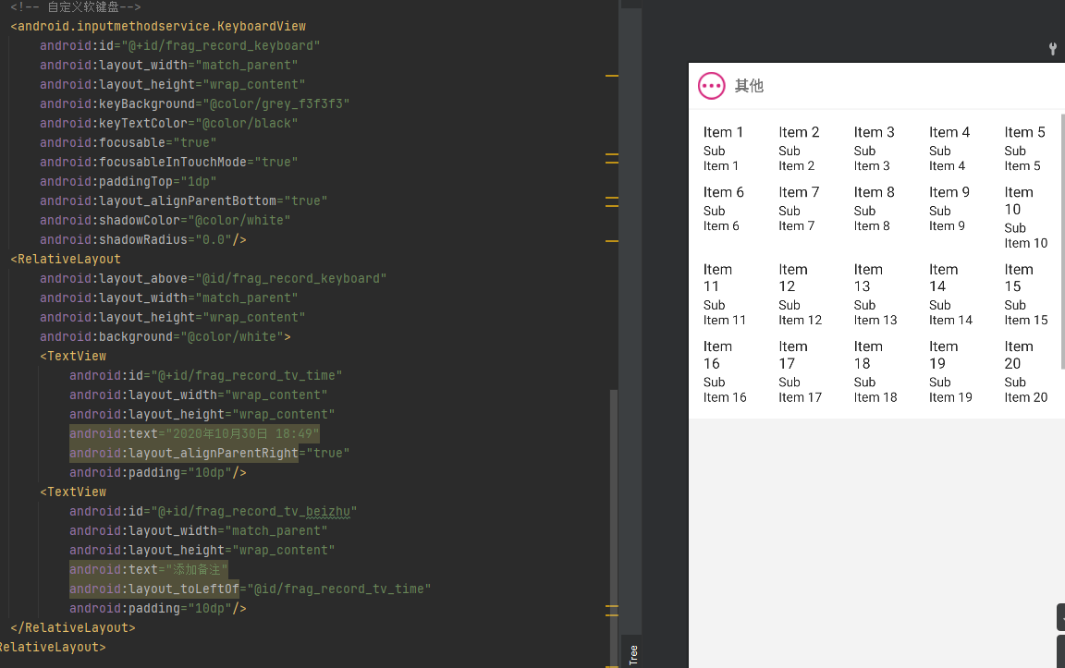
As for the implementation of the database, we chose SQLite because its featuring lightweight and embedded, and is easy to operate. In SQLite, after a table is defined, the type of data does not need to be claimed. When a data is plugged in, it will automatically find the type of data and store it properly. Also, as it’ s embedded, there are no service terminal or servers managing data. The application interact with database engine by function calls. The SQLite database concentrate on reliability, economic and efficiency, which properly supports what we have learnt in classes about agile programming and reliable programming. The following shows certain actions of the database.
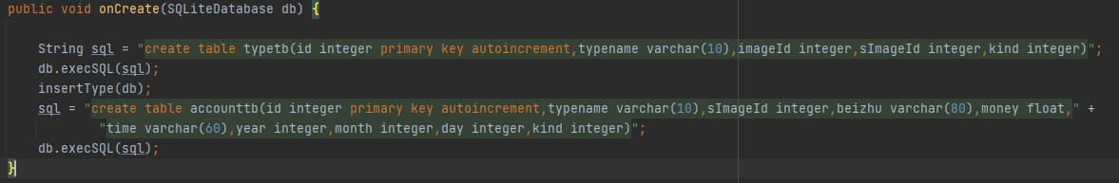
1.create database
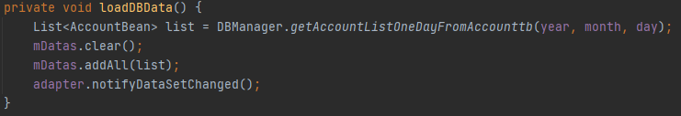
2.load database data in MainActivity
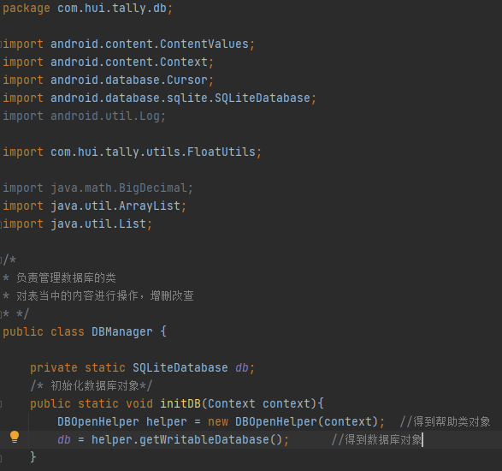
3.database management
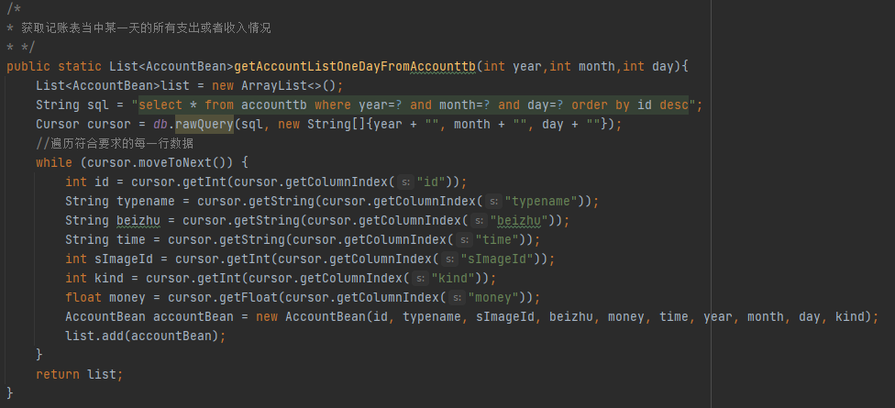
4.instance(get income and expenses of a certain day)

2.4 Testing
In Android studio there is a unit test part which supports both units requiring android api and java code functions. However, due to my limited information I haven’ t fully understand how it works. The following is the example generated automatically.
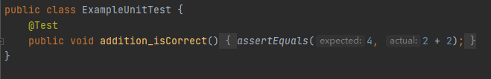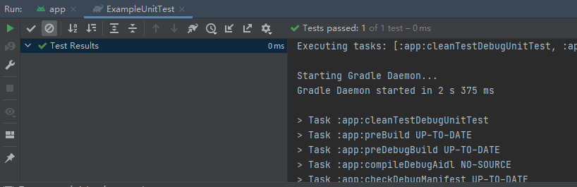

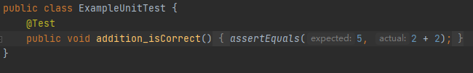
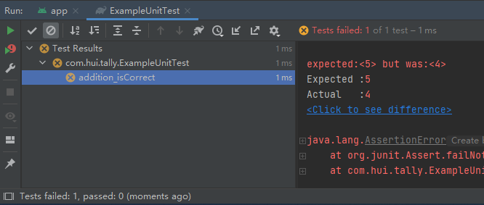

Conclusion
In conclusion, throughout a semester I have gained much knowledge about software engineering, including how a development team works, how the projected is decided and the procedure of a whole project.
I have learnt that to develop a fully functional software requires team work of many member and different sights. Also, multiple developer means multiple styles of codes. In the process of coding, software engineers should not only focus on implementation, but also work on agile development, readable coding and reliable programming. As software engineers, we should consider the simplicity and trust the team members, while never expect everyone to program in the same style as ours.
Granted that one people can develop a complete software all alone, the workload will be much larger compared with teamwork. From the lesson I learned much that might will be rather useful in my future career. After all, working as a programmer is meant to work with others.

Bibliography
[1] 黑马程序员．Android移动开发基础案例教程 ．中国工信出版集团，人民邮电出版社，2017.1．
[2] nieweilin．Android中的数据库操作． CSDN．
https://blog.csdn.net/nieweilin/article/details/5919013?utm_source=app&app_version=4.21.1
[3]陌路~天涯．Android studio利用MPAndroidChart制作简单柱形图．CSDN
https://blog.csdn.net/le9406/article/details/102833574?utm_source=app&app_version=4.21.1
[4]Mr Lee_．Android使用fragment实现界面的跳转
https://blog.csdn.net/qq_42889476/article/details/89323641?utm_source=app&app_version=4.21.1
[5]Ashraff Hathibelagal．Create a Custom Keyboard on Android
https://code.tutsplus.com/tutorials/create-a-custom-keyboard-on-android--cms-22615

本科生课程论文成绩评定
任课教师评语：

评定分数:
任课教师签字：
年 月 日
注：此页装订在论文最后一页

